**Virtualization**

Virtualization is a kind of technology that is rapidly transforming the IT landscape and has changed the way people compute. It reduces hardware utilization, saves energy and costs and makes it possible to run multiple applications and various operating systems on the same SERVER at the same time. It increases the utilization, efficiency and flexibility of existing computer hardware.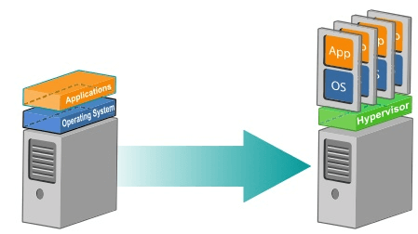

BENEFITS OF VIRTUALIZATION

1. More flexible and efficient allocation of resources.

2. Enhance development productivity.

3. It lowers the cost of IT infrastructure.

4. Remote access and rapid scalability.

5. High availability and disaster recovery.

6. Pay per use of the IT infrastructure on demand.

7. Enables running multiple operating system.

What makes virtualization possible?

There is software that makes virtualization possible. This software is known as a Hypervisor, also known as a virtualization manager. It sits between the hardware and the operating system, and assigns the amount of access that the applications and operating systems have with the processor and other hardware resources.

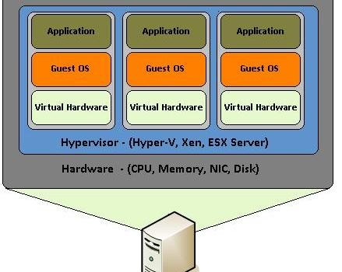

It would be easier to understand virtualization once we know about different types of virtualization, which are as follows –

Types of Virtualization:

1.Application Virtualization.

2.Network Virtualization.

3.Desktop Virtualization.

4.Storage Virtualization.

1. Application Virtualization:

Application virtualization helps user to have a remote access of an application from a server. The server stores all personal information and other characteristics of the application, but can still run on a local workstation through internet. Example of this would be a user who needs to run two different versions of the same software. Technologies that use application virtualization are hosted applications and packaged applications.

**Benefits of app virtualization**

App virtualization can be an effective way for organizations to implement and maintain their desktop applications. One of the benefits of application virtualization is that administrators only need to install an application once to a centralized server rather than to multiple desktops. This also makes it simpler to update applications and roll out patches.

Example :

[**Microsoft Application Virtualization**](https://www.trustradius.com/products/microsoft-application-virtualization/reviews)

21 Ratings

Microsoft App-V supports the virtualization of applications, making them available to end users without an installation.

* [Microsoft Application Virtualization Alternatives](https://www.trustradius.com/products/microsoft-application-virtualization/competitors)

[](https://www.trustradius.com/products/ceedoclient/reviews)

[**CeedoClient**](https://www.trustradius.com/products/ceedoclient/reviews)

We don't have enough ratings and reviews to provide an overall score.

CeedoClient from Israeli software company Ceedo supports application virtualization for enterprises or personal use, essentially allowing apps to run without installation.

2. Network Virtualization:

The ability to run multiple virtual networks that each has a separate control and data plan. It co-exists together on top of one physical network. It can be managed by individual parties that potentially confidential to each other.  
Network virtualization, provides a facility to create and provision virtual networks—logical switches, routers, firewalls, load balancer, Virtual Private Network (VPN), and workload security within days or even in weeks.

**Benefits**

Less Time, Effort, and Money Spent on Hardware

Hardware is one of the most expensive costs associated with running an IT department, just after the price of your IT workforce. [Virtualization](https://enterprise.netscout.com/expertise/topic/virtualization) cuts out the need for lots of physical switches, routers, servers, etc. -- not only saving the costs of maintaining and replacing those items, but also eliminating the costs of powering those devices and paying for repairs.

**Less Demand for Lots of Different Technical Skills**

Along with the hardware you eliminate through virtualization, you also eliminate the need to have workers trained across brands and models of all that hardware. Each time you invest in new switches, routers, and other equipment, you have to account for the time and expense of training IT workers to install, maintain, and repair that equipment. Virtualization takes care of this issue once and for all.

**Improved Security**

Another benefit of automation is that network policies, policies governing compliance issues, and security policies can be automated, as well. This [improves the security of a virtualized network](http://www.infoworld.com/article/2609571/networking/4-ways-network-virtualization-improves-security.html).

**Improved Recovery Times Following a Hardware Failure or Disaster**

Outages caused by hardware failures or some sort of a disaster can be tremendously costly. A virtualized network helps get your systems and applications back up faster.

3. Desktop Virtualization:

Desktop virtualization allows the users’ OS to be remotely stored on a server in the data center. It allows the user to access their desktop virtually, from any location by different machine. Users who want specific operating systems other than Windows Server will need to have a virtual desktop. Main benefits of desktop virtualization are user mobility, portability, and easy management of software installation, updates and patches.

Benefits

**1. Cost Savings**  
From an IT perspective, virtual desktops help reduce the time it takes to provision new desktops, and they also help to decrease desktop management and support costs.

**2. Simplified Management**Since everything is centrally managed, stored and secured, virtual desktops eliminate the need to install, update and patch applications, back up files and scan for viruses on individual client devices. Desktop virtualization also helps to streamline management of software assets.

**3. Enhanced Security**[Virtual desktops provide greater security](http://www.smallbusinesscomputing.com/webmaster/article.php/3914891/What-is-a-Virtual-Desktop-and-Why-Should-You-Care.htm) to an organization virtual desktops give medical personnel access to patient records without concerns about confidential information being downloaded. Since user data is backed up centrally and regularly, desktop virtualization also provides data integrity benefits.

**4. Increased Productivity**Virtual desktops allow employees to access applications and documents from multiple devices, including other desktop computers, laptops, tablets, and smart phones. This increases productivity by allowing workers to access necessary data from anywhere. As a result, whether employees are in another building, another state, or halfway across the globe, a virtualized desktop allows them to be productive in any environment. Plus, if an employee’s device is defective, they can merely log in from another device and continue working because the data was not stored locally.

4. Storage Virtualization:

Storage virtualization is an array of servers that are managed by a virtual storage system. The servers aren’t aware of exactly where their data is stored, and instead function more like worker bees in a hive. It makes managing storage from multiple sources to be managed and utilized as a single repository. Storage virtualization software maintains smooth operations, consistent performance and a continuous suite of advanced functions despite changes, breaks down and differences in the underlying equipment.